**Green and Gold Energy**

**Suncube Updater 3v1 Manual**

**Documentation**

**David Milanese**

Contents

Graphical User Interface 2

Start Menu: 2

Selection Menu 3

How to Guide 4

Selecting a Comm Port 4

Troubleshooting 4

Selecting Suncubes 4

Selection Guide 5

Troubleshooting 5

Executing Commands 6

Practical Applications 6

Administrator Info 8

Preparing data for Suncube Update3v1 8

Entering Suncubes 8

Using Excel 8

Sorting in Excel 9

Filtering in Excel 10

Apendix 1 – List of commands 1

# Graphical User Interface

## Start Menu:

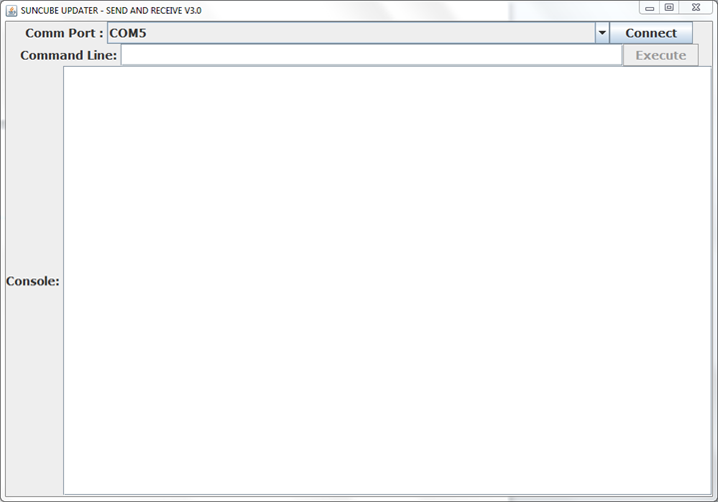

1

3

4

2

1. **Comm Port Combo Box** : Provides a drop down list of all available RS323 (Serial) ports on the machine. Any ports *disconnected* ports or *ports in use* will not appear. NB: If the Suncube Updater 3v1 has loaded and no ports are available, a continuous check for available ports will occur until at least 1 port is available.
2. **Connect/Disconnect Button** : Disconnects/Connects via your RS323 (Serial) device on the selected port in *item 1*. Failure to connect will result in a message displayed in the Console. Connection and disconnection messages will appear in the Console
3. **Command Line** : Sends commands in text format via RS323 (Serial) device
4. **Console** : Displays input, output and error messages. Outgoing messages lead with “OUT >”, incoming messages lead with “IN <”. *NB “OUT >” and “IN <” are not sent or received via any external device*

## Selection Menu

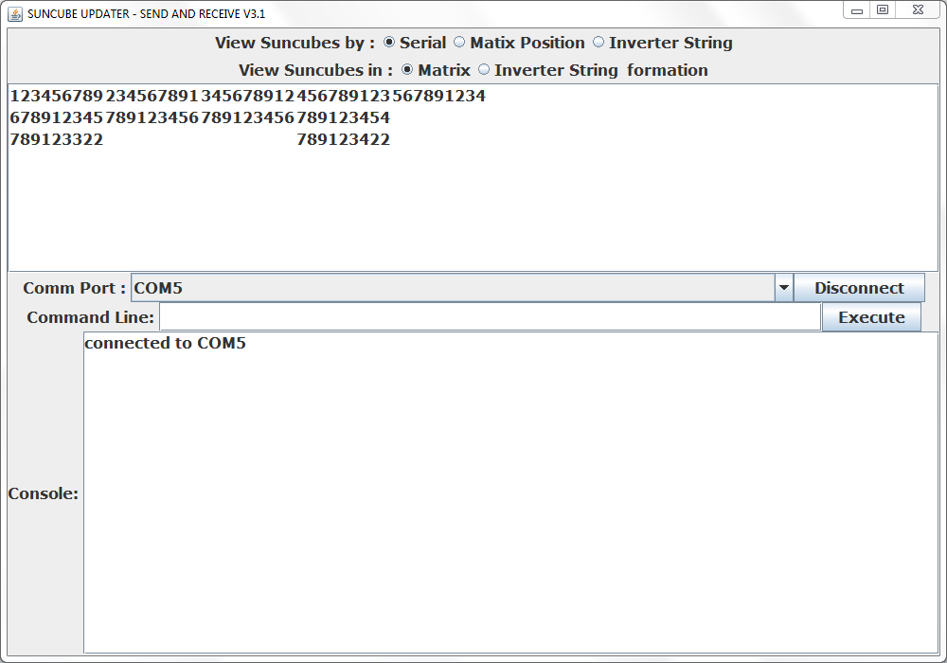

1

3

4

11

2

9

5

6

7

8

10

1 – 4 : See Start Menu on page 2

1. **View Suncubes by Serial Button** : Displays all Suncubes serial number in the list (item 10).
2. **View Suncubes by Matrix Position Button** : Displays all Suncubes physical position in the format “00AA” where 00 is the row and AA is the column.
3. **View Suncubes by Inverter String Button** : Displays all Suncubes inverter string number.
4. **View Suncubes in Matrix Button**: Orders all Suncubes by their physical position and displays them accordingly.
5. **View Suncubes in Inverter String Button**: Orders all suncubes by what string number they are on and displays them accordingly. Each column represents a different inverter string number.
6. **Suncube List** : Interactive list which can perform multiple selections. See selection guide(page 5) on how to make selections
7. **Execute Button** : Commits the text in the command line (item 3) followed by the selected Suncubes in the list (item 10) via the RS323 (Serial) device. The commands will be logged on the console.

# How to Guide

## Selecting a Comm Port

Selecting a Comm Port is the first step in the Suncube Updater. Selecting a Comm Port allows the user to interact with other devices connected on the other end of the port. To select a Comm Port from the drop down menu

1. Click on the downwards arrow located on the Comm Port combo box. 
2. Click on one of the avaliable options

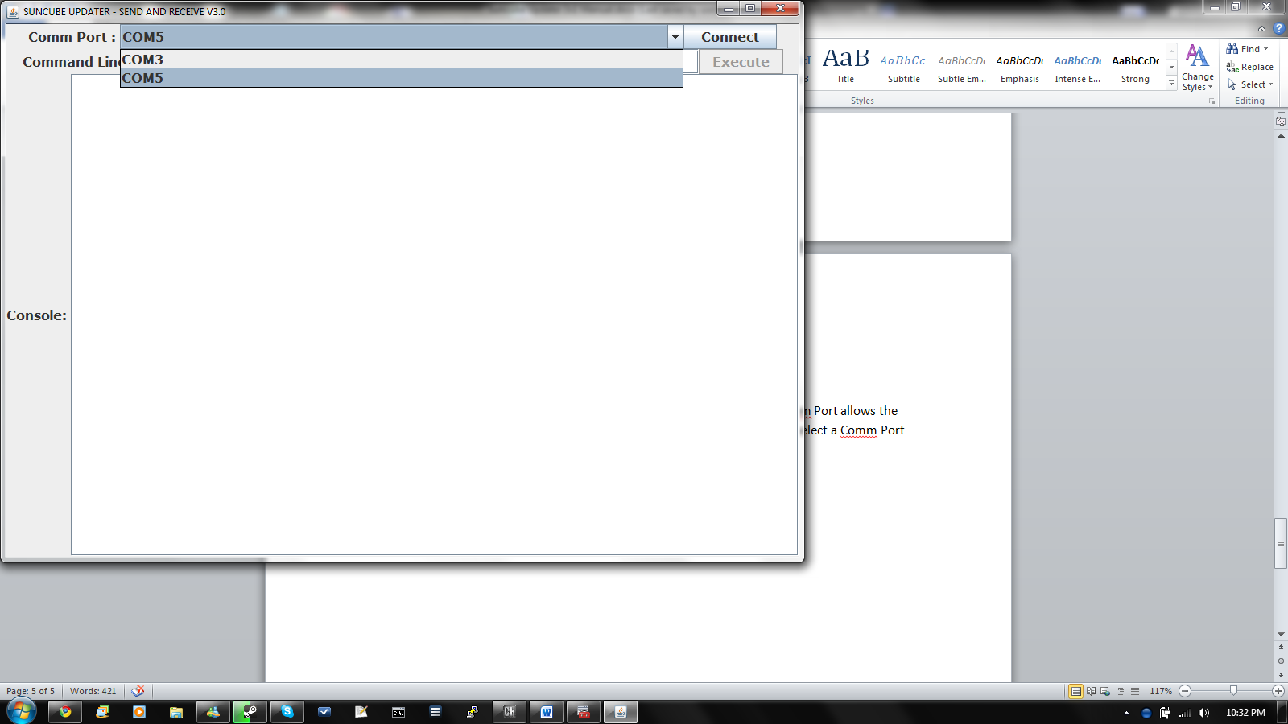

1. Click *Connect* to connect to comm port.    
   In the example selected port is COM5
2. A message will appear in the *Console* verifying that the connected was successful.



### Troubleshooting

**Q. I have no ports available in the Comm Port list**A. This means that there are no Comm Ports available. Check that the RS323 (Serial) device is plugged in and working. The Suncube Updater 3v1 will continue to check if there a new comm ports available until at least 1 port is available. If you have multiple Suncube Updater 3v1’s open and connected to comm ports. The ports will because unavailable for the Suncube Updater 3v1’s loaded at a later time, since a comm port can be used by 1 program at any given time.

**Q. When I clicked connect I got an error message “Failed to connect to comm”**A. Between the time when the list of Comm Ports is generated to when the connect button is clicked leaves the port venerable to failure on connection when the RS323(Serial) device is unplugged or stopes working in that time.

## Selecting Suncubes

Once the Suncube Updater 3v1 has connected to a comm port it will provide options to view the Suncubes by their Serial number, matrix position (row, columns), inverter string number and also to order the Suncubes by their matrix position or inverter string.

1. Select the attribute in which to display the Suncubes by 
   1. Serial is a unique 9 digit number to uniquely identify individual Suncubes
   2. Matrix position is a 4 char word in the format “00AA” where 00 is the row, and AA is the column.
   3. Inverter string is the string number that each Suncube is connected to from inverter
2. Select the ordering for the Suncubes
   1. Matrix orders all the Suncubes in a grid formation where each suncubes is uniquely defined by its row and column number
   2. Inverter string orders all Suncubes in columns such that each column represents individual strings on the inverter. If there are no Suncubes on a string number the column will be skipped

Selecting the Suncubes via the list. The matrix ordered list has its selection direction horizontally (left to right), whereas the inverter string ordered list has its selection direction vertically (up to down).

### Selection Guide

1. To select a single Suncube click on the Suncube on the list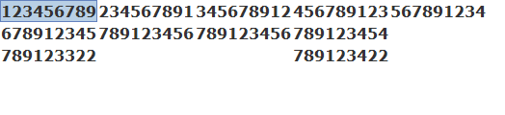
2. To select addition/multiple Suncubes hold CTRL and click on the Suncubes on the list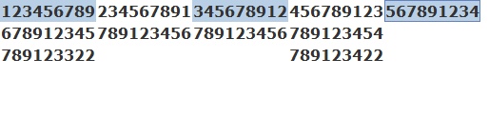  
   Inversely clicking on the Suncube again will deselect it whist holding CTRL
3. To select between 2 Suncubes Click on 1 Suncube (Step 1), Hold SHIFT, then Click on the next Suncube  
   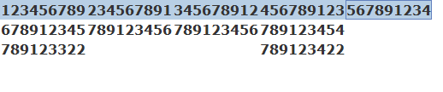
4. To select multiple rows or columns.
   1. Hold CTRL and click on a Suncube
   2. whilst holding CTRL press and hold SHIFT and click on another Suncube in the row or column  
      
   3. Then release the SHIFT key
   4. Click on a Suncube
   5. 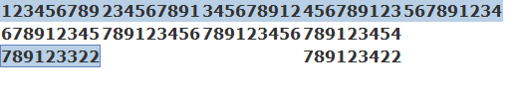
   6. Repeat steps b, c, d as many times as you like   
      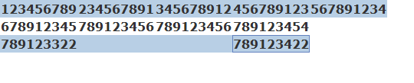

Note that any black selections such as the second select row in figure f. will be ignored.

### Troubleshooting

**Q. Whilst holding SHIFT to select a group of Suncubes in the same column (in matrix ordering) all the rows between the end Suncubes are selected.**  
A. Note above where it says how the ordered lists have section direction. For the horizontal direction selection lists the next Suncube in the list is either to the left or right (exception at the ends of a row). The holding SHIFT function selects all the Suncubes **between** a pair of Suncubes. So as far as the computer is concerned from the first Suncube all the Suncubes horizontally after that Suncube will be selected until the last Suncube.

## Executing Commands

The command line acts as a way to set and request data to and from the Suncubes. The output of the commands will be directed to selected Suncubes via their serial number. This allows for multiple Suncubes to be connected on the one port without any discreptences amongst other Suncubes.

1. Select Suncube(s) (see *Selecting Suncubes*)
2. Enter a command in the command line 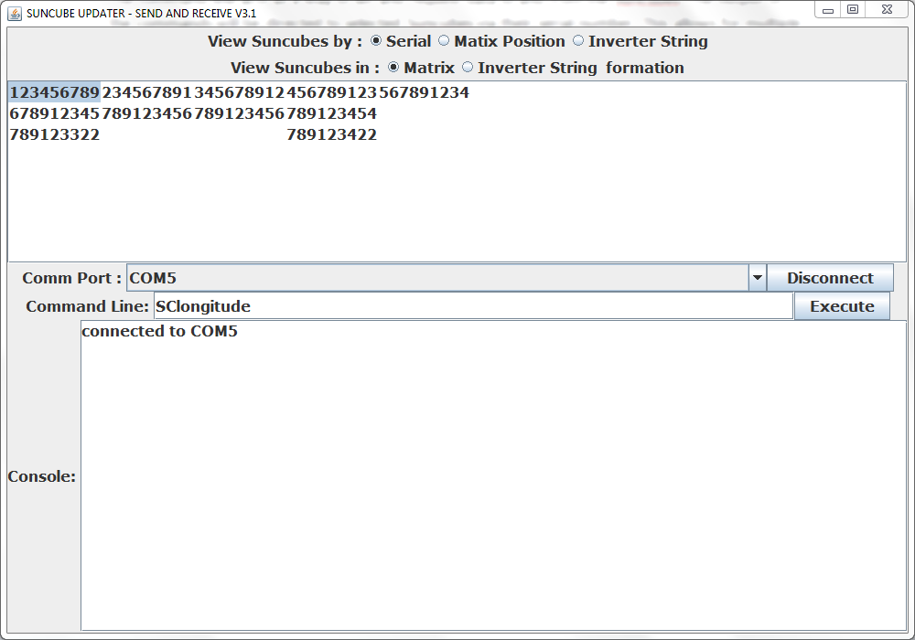
3. Click the *Execute* button 
4. The output is displayed in the *console*  
   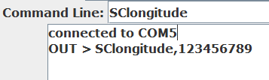

The Suncubes Updater 3v1 can execute a command to several Suncubes at once. This can be done by selecting multiple Suncubes in the Suncubes list.

### Practical Applications

To see the Suncube Updater 3v1 in action lets take a realistic sceanario.

**There is a problem with one of the Suncubes in the 3rd inverter string. The Suncubes need to be set to sleep mode before performing any maintenance.**

1. Connect RS323 (Serial) device and connect to the Comm Port. 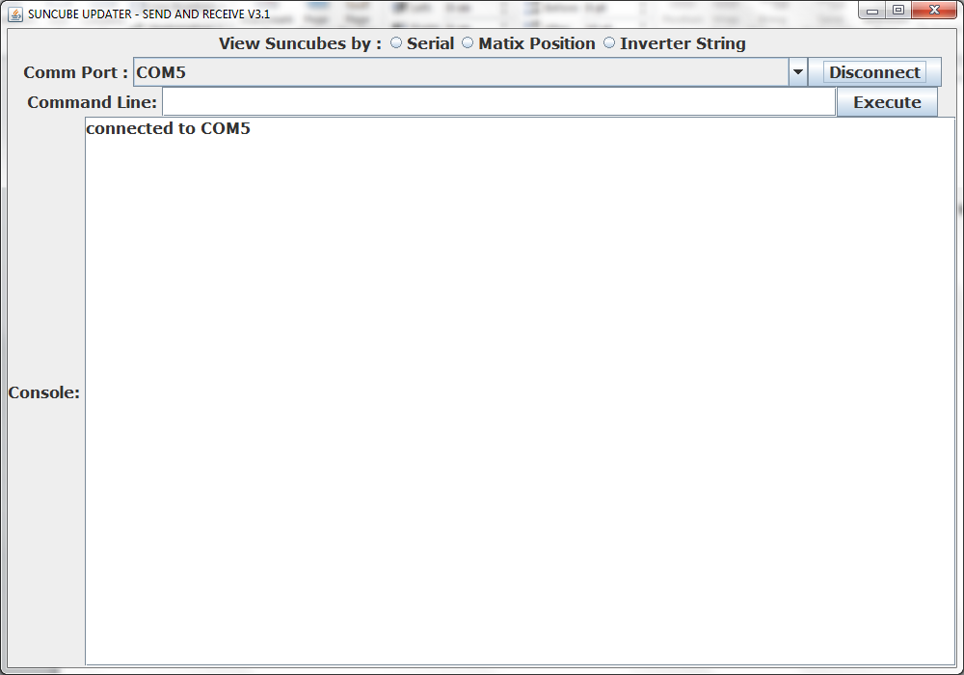
2. Click the view Suncubes by *Inverter String* radio button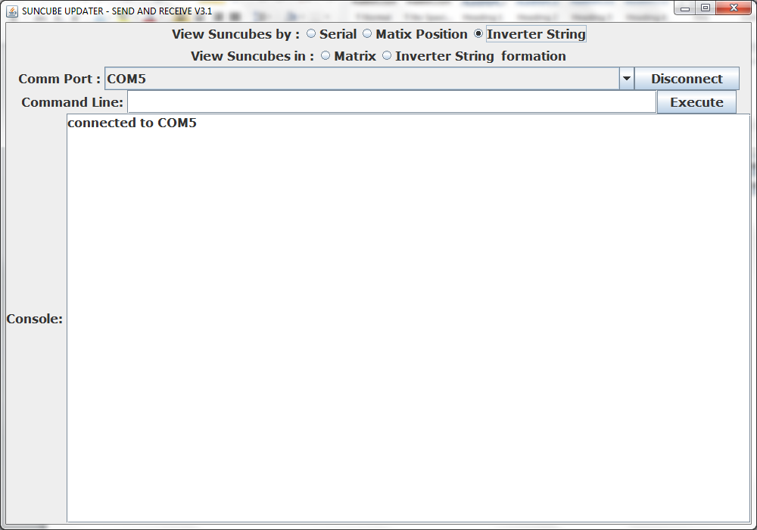
3. Click the view Suncubes in *Inverter String* radio button
4. 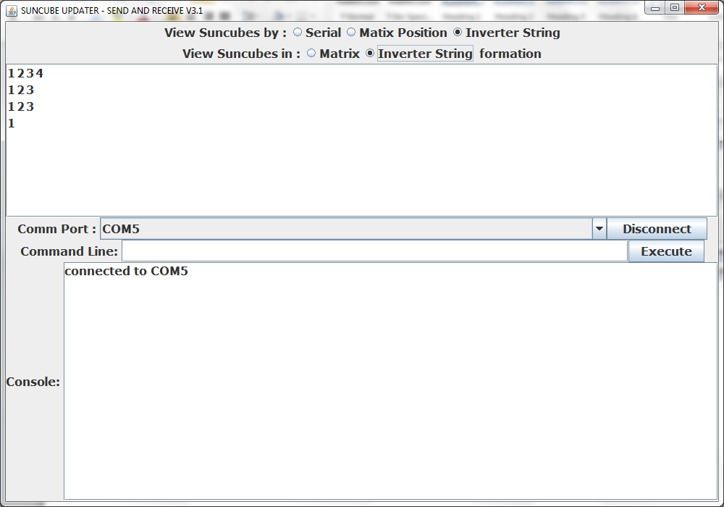
5. Select the first Suncube in the column with all 3’s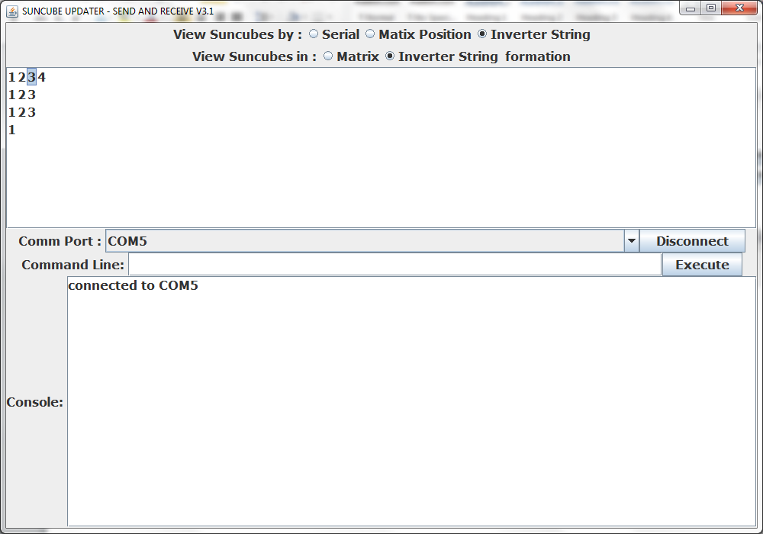
6. Whist holding the SHIFT key, select the last Suncube in the same column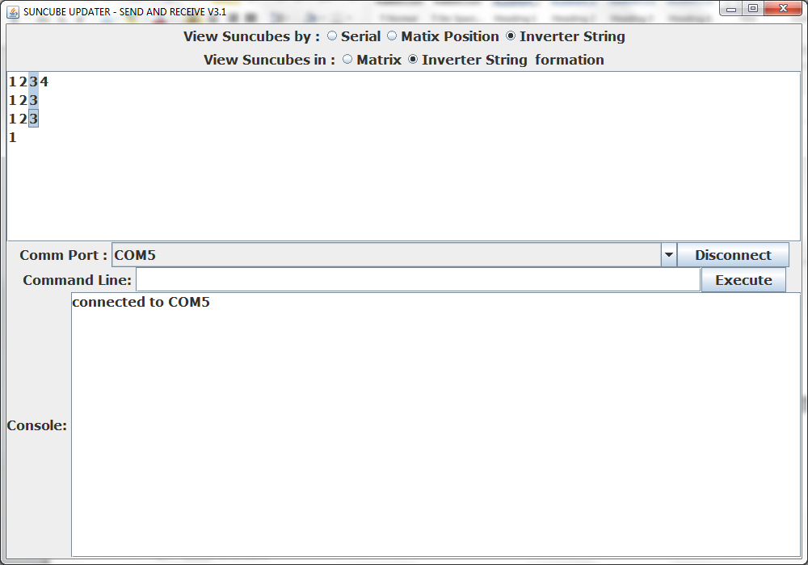
7. Type “SCsleep” in the *command line*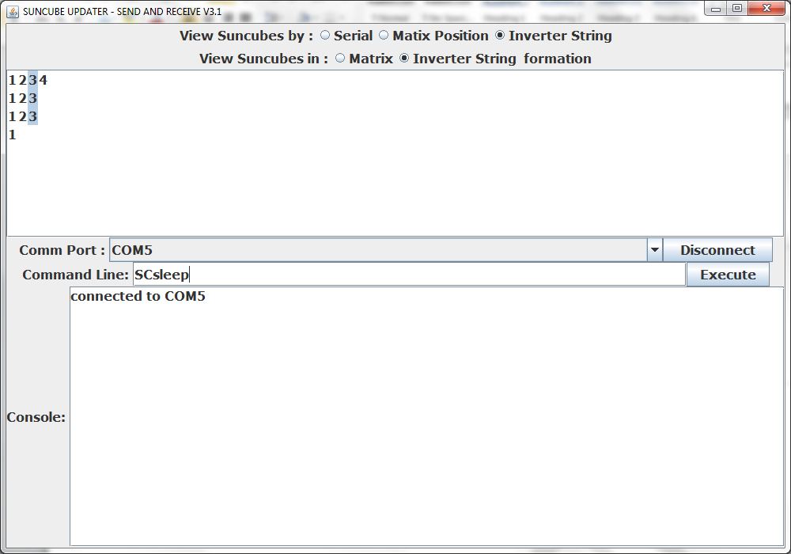
8. Click the *execute* button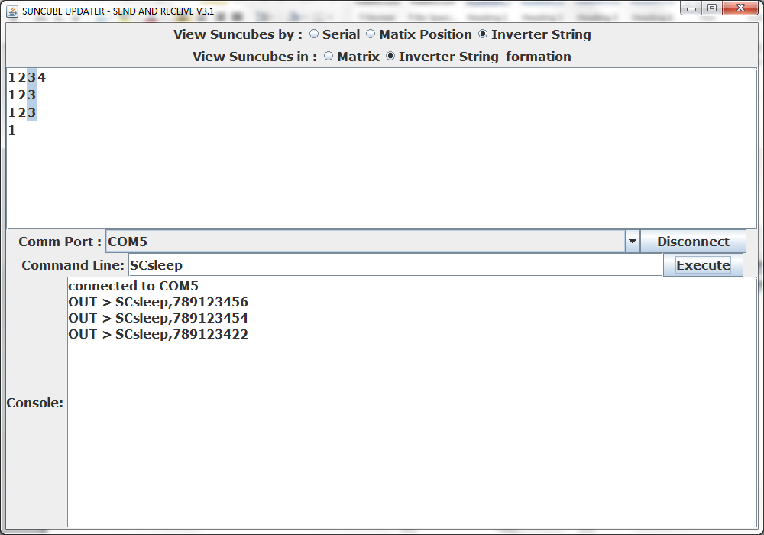

# Administrator Info

## Preparing data for Suncube Update3v1

The Suncube Updater 3v1 reads in all the Suncubes from a comma separated value (CSV) file named “suncubes.csv”. This file must be placed in the *src* folder which can be in the Suncube Updater 3v1 folder. *NOTE: do not attempt to open or edit any other files without permission.*

## Entering Suncubes

To enter Suncubes such the the Suncube Updater 3v1 will read all the inputs correctly each Suncube element needs to be on 1 line per Suncube and separated by 1 comma per pair of elements. The format is shown here:

*********,XXYY,##

* ********* := Suncube serial number (must be 9 characters long)
* XXYY := Suncube matrix position (must be 4 characters long)
* ## := Inverter string number (can be 1 or 2 digits long)

*NOTE: any entries that do not follow the requirements above will be skipped, and an error message will be displayed in the console when the Suncube Updater 3v1 loads.*

*NOTE: an empty line or end of file will terminate the importing process*

There are 2 ways to enter the data into a CSV file.

1. Using a text editor (such as notepad). If you choose this method be aware to save as a CSV file.
2. Using Microsoft Excel

Excel is the preferred choose as it has a fully featured interface and options.

## Using Excel

In Microsoft Excel denote the first column for the Suncube Serial number, the second column for the matrix position and the 3rd for inverter string number. Any text or input in any of the other columns will be ignored.

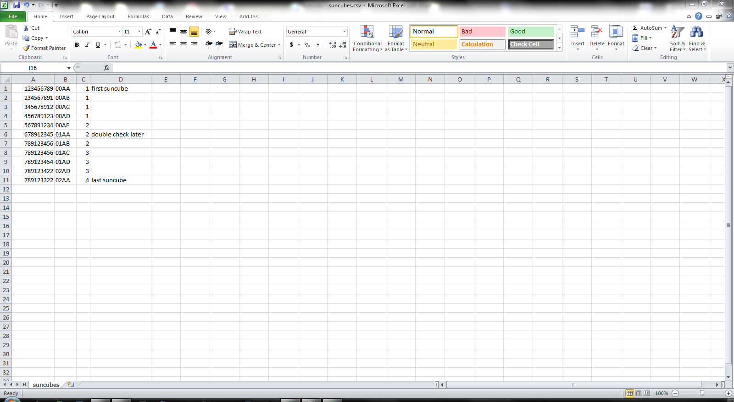

### Sorting in Excel

Excels sorting tool allows us to sort any column in ascending or descending order. The ordering of the data does not matter. To do this in Excel:

1. Select the column to be ordered (Click on the column header I.e B in the picture below)  
   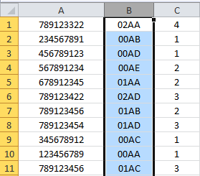
2. Click sort in ascending or descending order  
   
3. A dialogue box will appear, continue by clicking Sort  
    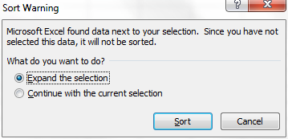
4. The selecte column is now sorted  
   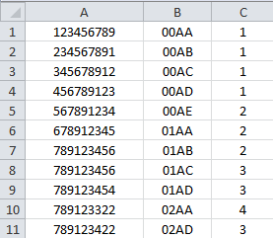

### Filtering in Excel

Excel filtering tool allows us to filter out specific Suncubes with specific elements. To do this:

1. Select a column to filter  
   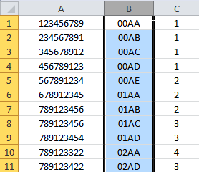
2. Click the Filter button  
   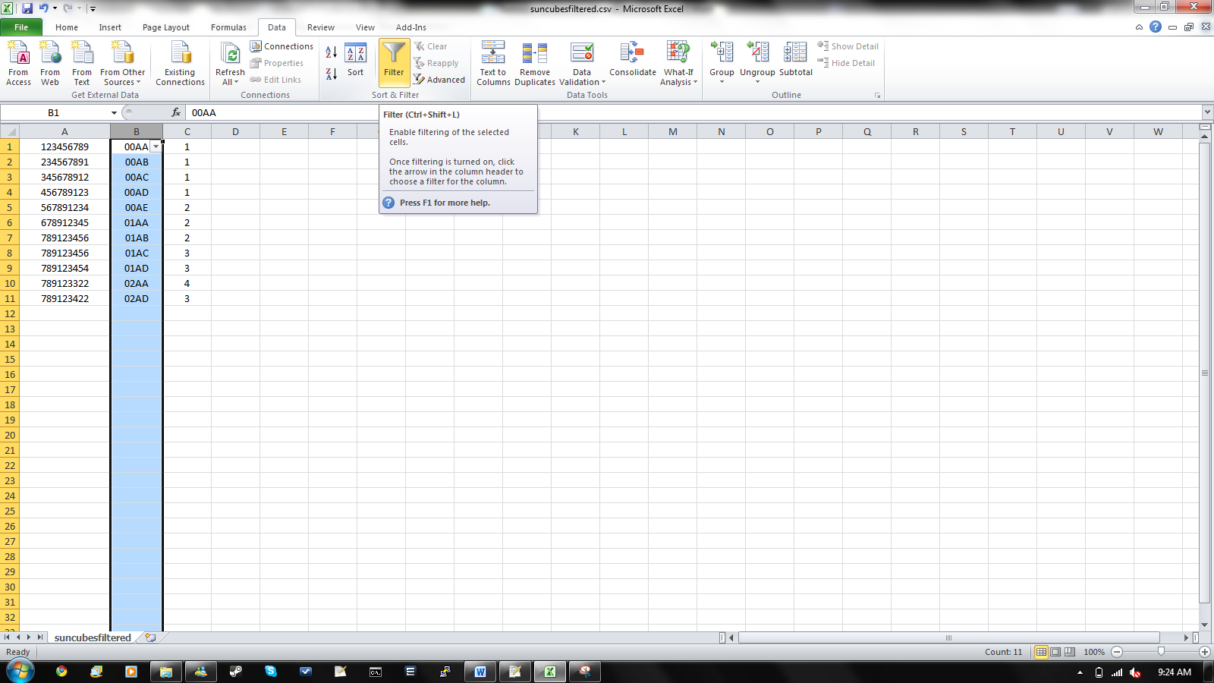
3. Click on the drop down menu in the selected column  
   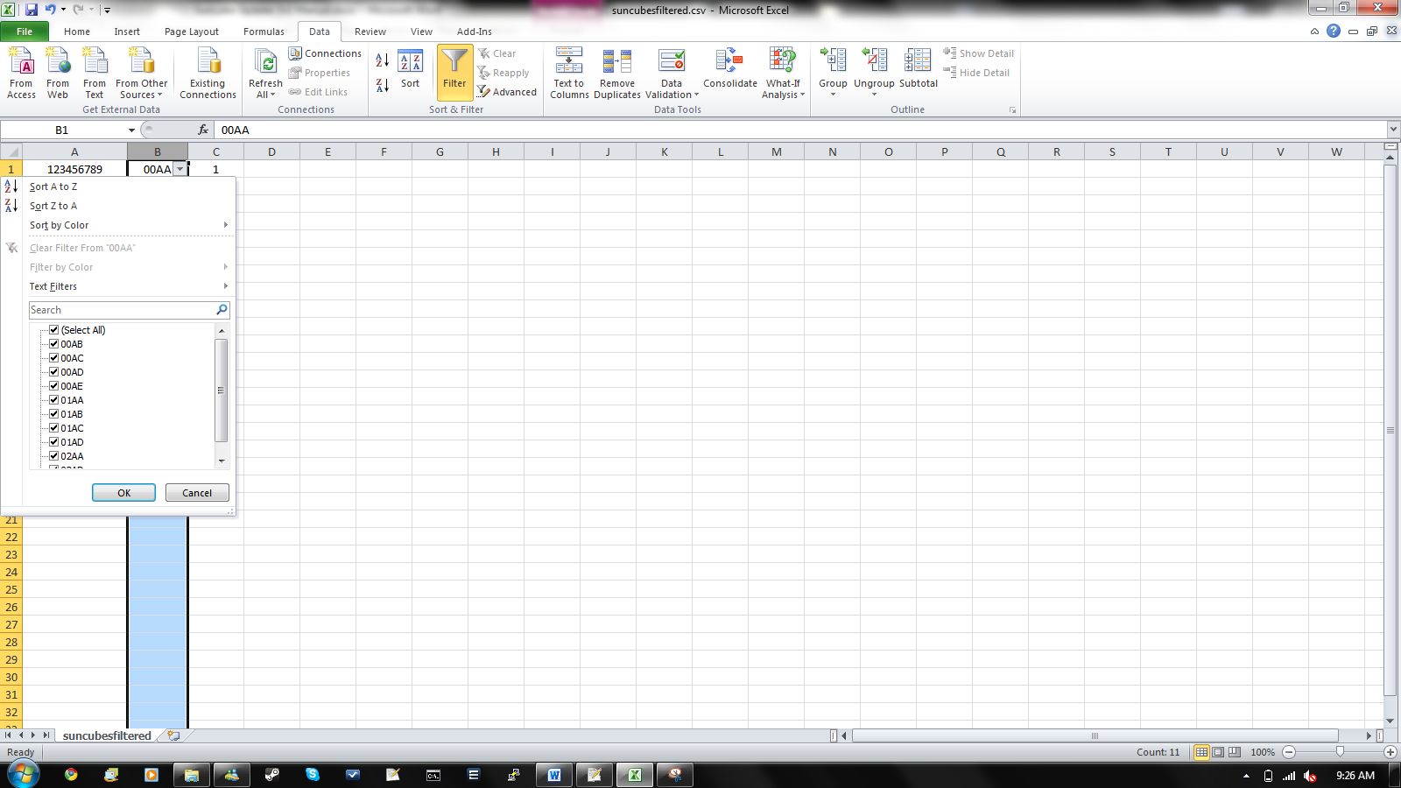
4. Enter an appropriate sequence in the Search text field (i.e all Suncubes with “AA” in its matrix position), and click Ok  
   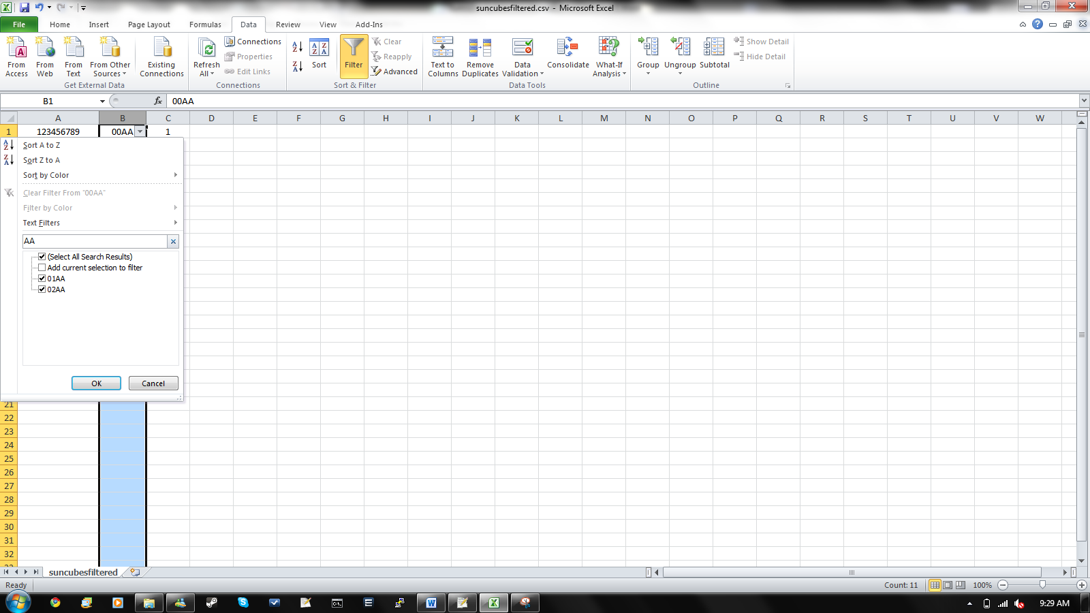
5. The new list appears  
   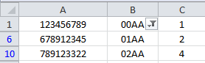

To clear the filter click on the  button near the top filtered column then *clear filter from “****”*

*NOTE: saving whist filter is active will save all the visible and non-visible entries in the spread sheet.*

# ­Apendix 1 – List of commands

|  |  |  |
| --- | --- | --- |
| Command | Command Description | Expected Response |
| SCsleep | Orders Suncube to go to sleep mode |  |
| SCsunlock | Orders Suncubes to obtain sun lock |  |
| SClong | Requests Suncubes longitude | *********,±XXX.XXXX |
| SCLati | Requests Suncubes latitude | *********,±XXX.XXXX |
| SCtime | Requests Sucnubes current time | *********,XX:XX:XX:XXX |
| SCsetTime | Sets Suncube with current time |  |
| SCsetLong±XXX.XXXX | Sets Suncube longitude to ±XXX.XXXX |  |
| SCsetLati±XXX.XXXX | Sets Suncube latitude to ±XXX.XXXX |  |

********* := the Suncubes serial number

X : = Numeric character (0-9)

± := plus (+) or minus (-)